Chapters and Verses

Virtual Bookshop

DTB

Markel Fernandez, Alex Irusta, Fran de Ysasi and Leire Carrasco

22/05/27



Índex

**Statement** **3**

**E/R** **4**

**Relational** **5**

**Normalization** **6**

**Creation of DB, tables + insert** **7**

# Statement

The Basque Country bookstore network offers the development of an application for bookstore management. The Tartanga Institute will propose the best solution for said application developed within the development teams of the Multiplatform Application Development groups.

The objective of this application is to support some of the functions that are usually available in virtual libraries that exist on the Internet. As basic functions of the application we could highlight the insertion of new books in the bookstore and the management of their prices and stock, the search for books that may interest the user and the purchase of those books.

Access to the application must be restricted only to those users who have previously registered.

# E/R



# Relational

- Users (username(PK), passwd, type)

- Member (username(PK)(FK), name, surname, address, phone, e-mail, accountNumber, preferencesAuthor, preferencesGenre, active)

- Administrator (username(PK)(FK), yearsWorked)

- Book (isbn(PK), title, descrip, editorial, publiDate, price, offer, discountRate, stock, nameG(FK), codAu(FK), active)

- Genre(codG(PK), nameG, active)

- Author (codAu(PK), nameA, surname, birthDate, deathDate, active)

· Purchase (isbn(PK)(FK), username(PK)(FK), datePurchase, cant)

# 

# Normalization

First Normal Form (1NF)→

*It is said that a relationship is in 1NF if all its attributes are atomic: (There are no data groups: Each tuple has only one value).*

*This database is in 1NF.*

Second Normal Form (2NF)→

*A relationship is in 2NF if it is in 1NF and the attributes that are not primary key depend entirely on the primary key. There are no partial functional dependencies regarding candidate keys:*

*This database is in 2NF.*

Third Normal Form (3NF)→

*It is said that a relationship is in 3NF if it is in 2NF and any attribute that is not part of a candidate key depends directly on it. There are no transitive functional dependencies between attributes that are not key.*

*This database is in 3NF.*

# Creation of DB, tables + insert

·USERS·

CREATE TABLE users

(

username VARCHAR(20) NOT NULL PRIMARY KEY,

passwd VARCHAR(20) NOT NULL);



INSERT INTO users VALUES

('MarKKus', 'MarkelAdmin'),

('hhellyeahh', 'LeireAdmin'),

('Alexito', 'AlexAdmin'),

('Frankcisko', 'FranAdmin'),

('OmenGatito', 'ZuluMember'),

('OTPBreach', 'BonillaMember'),

('Carmensita', 'CarmenMember');

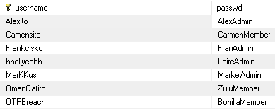

·MEMBER·

CREATE TABLE member

(

username VARCHAR(20) NOT NULL PRIMARY KEY,

name VARCHAR(15) NOT NULL,

surname VARCHAR(15) NOT NULL,

address VARCHAR(20) NOT NULL,

phone INTEGER NOT NULL,

email VARCHAR(30) NOT NULL,

accountNumber VARCHAR(30) NOT NULL,

preferencesAuthor VARCHAR(20),

preferencesGenre VARCHAR(20),

active BOOLEAN NOT NULL,

FOREIGN KEY (username) REFERENCES users (username) ON DELETE CASCADE);

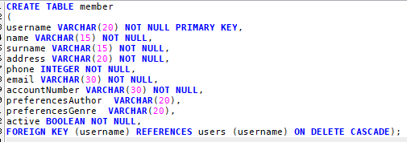

INSERT INTO member VALUES

('OmenGatito', 'Unai', 'Zuluaga', 'C. San Juan', 689854406, 'omengatito@gmail.com', 'ES77 7674 4532 45 1234567856', NULL, NULL, TRUE),

('OTPBreach', 'Unai', 'Bonilla', 'C. Santutxu', 634431891, 'unaibonilla@gmail.com', 'ES79 7674 4532 45 1234556344', NULL, NULL, TRUE),

('Carmensita', 'Carmen', 'Pascual', 'C. San Ignacio', 620825173, 'pascucarmen@gmail.com', 'ES02 7604 4532 87 1234567856', NULL, NULL, TRUE);



·ADMINISTRATOR·

CREATE TABLE administrator

(

username VARCHAR(20) NOT NULL PRIMARY KEY,

yearsWorked INTEGER NOT NULL,

FOREIGN KEY (username) REFERENCES users (username) ON DELETE CASCADE);

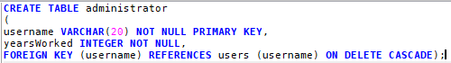

INSERT INTO administrator VALUES

('MarKKus', 37),

('hhellyeahh', 12),

('Alexito', 45),

('Frankcisko', 4);

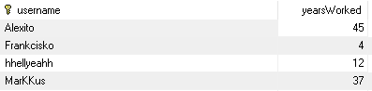

·BOOK·

CREATE TABLE book

(

isbn VARCHAR(20) NOT NULL PRIMARY KEY,

title VARCHAR(50) NOT NULL,

descrip VARCHAR(500),

editorial VARCHAR(20) NOT NULL,

publiDate DATE NOT NULL,

price INTEGER NOT NULL,

offer BOOLEAN,

discountRate INTEGER,

stock INTEGER NOT NULL,

codG INTEGER NOT NULL,

codAu VARCHAR(20) NOT NULL,

active BOOLEAN NOT NULL,

FOREIGN KEY (codG) REFERENCES genre (codG) ON DELETE CASCADE,

FOREIGN KEY (codAu) REFERENCES author (codAu) ON DELETE CASCADE);

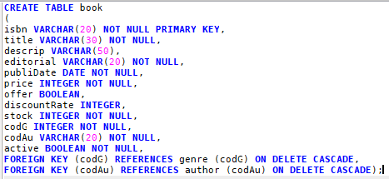

INSERT INTO book VALUES

('978-89-25285-64-1', 'ROMANCE DAWN-El amanecer de una aventura', 'Primer tomo del manga One Piece.', 'Shueisha', '1999-10-20', 6.6, FALSE, NULL, 67, 9, 'a01', TRUE),

('978-88-69183-15-7', 'Harry Potter y la Piedra Filosofal', 'Harry Potter se ha quedado huérfano y vive en casa de sus abominables tíos y el insoportable primo Dudley. Harry se siente muy triste y solo, hasta que un buen día recibe una carta que cambiará su vida para siempre. En ella le comunican que ha sido aceptado como alumno en el Colegio Hogwarts de Magia.', 'Salamandra', '1997-06-26', 14.25, TRUE, 10, 50, 3, 'a05', TRUE),

('978-00-03252-45-3', 'Romeo y Julieta', 'Romeo y Julieta trata de la historia de amor imposible entre dos jóvenes pertenecientes a dos familias de Verona enfrentadas desde tiempos inmemoriales: los Montesco y los Capuleto. Romeo Montesco conoce a la bella dama Julieta Capuleto en una fiesta y ambos se enamoran perdidamente el uno del otro.', 'Anaya', '1595-01-29', 11.5, FALSE, NULL, 10, 10, 'a02', TRUE);



·GENRE·

CREATE TABLE genre

(

codG INTEGER NOT NULL PRIMARY KEY,

nameG VARCHAR(40) NOT NULL,

active BOOLEAN NOT NULL);

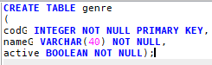

INSERT INTO genre VALUES

(1, 'Action and Adventure', TRUE),

(2, 'Detective and Mystery', TRUE),

(3, 'Fantasy', TRUE),

(4, 'Historical Fiction', TRUE),

(5, 'Horror', TRUE),

(6, 'Literary Fiction', TRUE),

(7, 'Romance', TRUE),

(8, 'Science Fiction', TRUE),

(9, 'Manga', TRUE);

(10, 'Tragedia', TRUE);

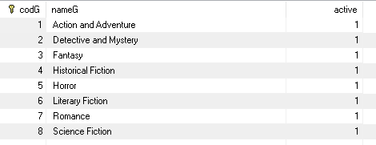

·AUTHOR·

CREATE TABLE author

(

codAu VARCHAR(20) NOT NULL PRIMARY KEY,

nameA VARCHAR(20) NOT NULL,

surname VARCHAR(15) NOT NULL,

birthDate DATE NOT NULL,

deathDate DATE,

active BOOLEAN);

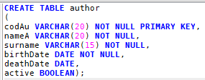

INSERT INTO author VALUES

('a01', 'Eiichiro', 'Oda', '1975-01-01', null, TRUE),

('a02', 'William', 'Shakespeare', '1564-04-23', '1616-05-03', TRUE),

('a03', 'Jules', 'Verne', '1828-02-08', '1905-03-24', TRUE),

('a04', 'Stephen', 'King', '1947-09-21', null, TRUE),

('a05', 'Joanne', 'Rowling', '1965-07-31', null, TRUE);

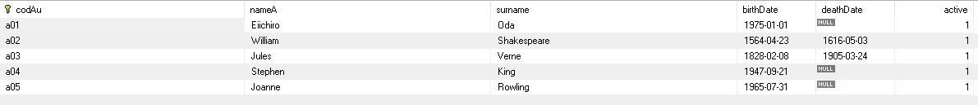

·PURCHASE·

CREATE TABLE purchase

(

isbn VARCHAR(20) NOT NULL,

username VARCHAR(20) NOT NULL,

datePurchase DATE NOT NULL,

cant INTEGER NOT NULL,

PRIMARY KEY (isbn, username),

FOREIGN KEY (isbn) REFERENCES book (isbn) ON DELETE CASCADE,

FOREIGN KEY (username) REFERENCES users (username) ON DELETE CASCADE);

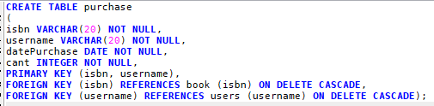

INSERT INTO purchase VALUES

('978-89-25285-64-1', 'Carmensita', '2022-04-05', 5),

('978-89-25285-64-1', 'OTPBreach', '2022-06-06', 2),

('978-00-03252-45-3', 'OmenGatito', '2022-02-14', 1);